What does it look like when young people have power? Reflections from a Scottish Youth Centre
Dr Lara Morcillo Sanchez, University of Girona
Dr Louise Sheridan, University of Glasgow
Abstract: This article critically examines the tensions surrounding youth empowerment within contemporary youth work practice. Although youth empowerment has become a widely recognised principle in youth policy and rights-based discourse, its implementation in everyday socio-educational contexts remains complex and often contradictory. Drawing on critical and relational approaches to youth work, the article argues that empowerment cannot be understood solely as an individual process, but must also address broader structural inequalities, unequal opportunities, and the conditions that shape young people’s participation and agency.The discussion is informed by the concept of alfirmo, understood as conveying belief in people’s capacity for positive change while providing care, compassion, and meaningful support. While youth work has long been associated with opportunities for personal growth and democratic participation, provision often continues to position young people as “citizens in training”, limiting the transformative potential of empowerment practices and their connection to wider community or structural change. This tension persists despite the radical tradition of youth work grounded in Paulo Freire's critical pedagogy and collective transformation. The article draws on two youth empowerment workshops conducted within a youth project: one involving seven young people and another involving fifteen youth workers. Through reflective discussion and qualitative analysis, the findings identify three key opportunities for youth workers to

challenge inequality and strengthen empowering practice: overcoming adult-centric discourses, fostering positive relational support, and creating reflective spaces within professional practice. The article concludes by emphasising the importance of relational, critical, and structurally aware approaches to youth empowerment in contemporary youth work.

Keywords: Empowerment, youth, youth workers, adultism
Introduction - How was this article born?
This article emerged from an international doctoral research stay undertaken by one of the authors at the University of Glasgow. Both authors are grounded in the fields of youth work and social practice, drawing on their professional experience to inform their academic and pedagogical perspectives. The article responds to an ongoing tension: although youth empowerment has become a widely recognised principle in youth policy and rights-based discourse - including its implicit recognition within the United Nations Convention on the Rights of the Child (1991) - its implementation in everyday socio-educational practice remains complex and often contradictory. Efforts to foster youth empowerment are shaped not only by the assumptions and expectations held by both young people and youth workers regarding their own capacity for agency and participation, but also by broader structural conditions marked by inequality, individualisation, and weakening forms of community engagement. Throughout the research stay, the authors collaboratively developed shared perspectives, working hypotheses,

and analytical frameworks that ultimately led to the design and facilitation of two youth empowerment workshops within a youth organisation, one involving young people and another involving youth workers. The reflections generated before, during, and after these workshops, together with the analysis of the sessions themselves, form the basis of this article.

Framing the Study – Perspectives on Youth: Conflict, Conformity or Opportunity?
Multiple perspectives of youth exist. Sociologically, young people can be seen as sources of social disruption, as citizens in training, or as key drivers of societal progress (James and McGillicuddy, 2001). These perspectives emphasise the need for a nuanced understanding of the approaches taken within youth work contexts. Young people may be viewed as disengaged, underperforming or as capable of achieving great potential with the right support. The views on young people held by youth workers shapes the way they work, and the outcomes for young people. Embodying ‘alfirmo’, which means ‘conveying the belief in people’s ability to achieve positive change, demonstrating care and compassion for people, and providing the necessary support when needed to help them achieve their goals’ (Sheridan and Mungai, 2021, p.6). Young people may represent an opportunity for community and societal development, particularly when provided with education and resources that meets their needs.
Youth policy has shifted from viewing young people as problematic to underlining young people as a positive resource (Dunne et al., 2014). Nevertheless, dominant groups continue to disregard young people’s potential. According to Corney et al. (2022, p.678), young people are ‘marginalised by the specific social, political, cultural and economic contexts in which they live’ and face adultism, in which adults are positioned as superior. Sheykhi (2021) emphasises the importance of understanding young people within their broader social context. Youth work

settings provide spaces in which to explore the intersecting factors that influence young people’s day-to-day experiences, usually under the banner of youth participation or youth empowerment approaches (Sala-Torrent and Planas-Lladó, 2024).

Youth Empowerment – We all know what it means? Right?
Empowerment has been a popular term since 1970s (Ciraso et al., 2023) and the body of research on youth empowerment has increased notably over the past 20 years (Planas-Lladó & Úcar, 2022). Planas-Lladó & Úcar (2022), and Jennings et al. (2006) call for a shift from viewing youth as passive recipients of services to active agents of change within their communities. Jennings et al (2006) identified 6 key dimensions of critical youth empowerment: 1) a safe environment, 2) meaningful participation, 3) power sharing between youth and adults, 4) critical reflection, 5) participation in the sociopolitical sphere and 6) integration of individual and community.
The concept of empowerment on which this study is based is the one developed by Soler et al. (2017). According to these authors:
‘Empowerment is a process that increases the chances of individuals being able to decide and act consistently on everything that affects their own life, participate in decision-making and intervene in a shared and responsible way in relation to that which affects the community of which they form a part. This requires two conditions: that individuals acquire and develop a series of personal capacities [...] and that the environment enables them to effectively exercise those capacities. (p. 22)
Planas-Lladó and Úcar (2022) constructed an inventory of 9 dimensions of youth empowerment shown in Table 1. In each field of action, educators can conceive empowerment

in different ways. This means they may attempt to enable the dimensions of empowerment in different ways.
Table 1 The 9 dimensions of youth empowerment by Planas-Lladó and Úcar (2022)
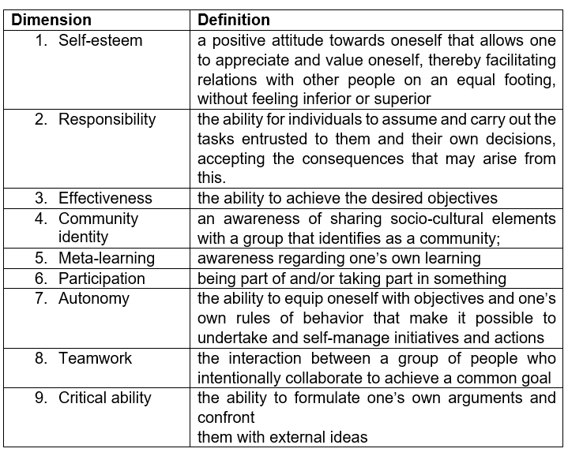
There is, however, consensus on the distinction between individual empowerment and community and social empowerment (Checkoway, 1997; Zimmerman, 2000). Ciraso et al. (2023) surveyed 696 educators from various contexts and focused on how educators can enable young people to empower themselves. They found that formal educators tended towards individual empowerment outcomes, whereas those in informal contexts focused more on collective and social empowerment in young people. Crouzé et al. (2022) also suggest that non formal educational spaces are a fertile site for practices of empowerment and engagement.

There is more capacity for flexibility in non-formal spaces, with less of a hierarchy than in formal contexts, also the immediate environment is the most important factor for enabling empowerment in young people (Llena et al, 2023) Young people in Sheridan’s (2018, p.211) study of youth participation practice in North Ayrshire, Scotland, greatly appreciated working with youth workers ‘on the same level’ still recognising that youth workers have professional boundaries. This reflects one of Freire’s (1996, p.129) principles - ‘the importance of pedagogical space’, which emphasises the need to create the right space in which young people can thrive.
Research suggests, the hardest to reach young people are often the most marginalised (Evans & Kruger, 2012). Ward et al’s. (2024) study shows how youth work in high-poverty communities is necessary and valuable to contribute to Scottish policy and to make the youth voice heard. The right for young people to participate is recognised and accepted in Scotland, United Kingdom and internationally (Lundy, 2018). However, not all the groups are equally engaged in civic development.

Research Design
The project took the form of a small, qualitative case study (Yin, 2012) involving participants from a purpose-built youth project that has operated for over 25 years in Scotland. The preliminary study, approved by a University of Glasgow Ethics Committee, was intended as a scoping exercise for a future project involving young people and youth workers from Glasgow, and from Girona. Purposive sampling (Campbell et al., 2020) was used to select the youth project; it is a long-established youth facility that promotes youth participation and involves young people in its Board of Directors. Two focus groups took place, one with young people (7 participants, aged 16 and 17 years old, who were doing a community-based learning unit as

part of their school curriculum) and the other with youth workers (15 participants, a mix of voluntary (young leaders), sessional, and full-time youth workers).
The focus groups with both young people and youth workers involved them working in pairs and trios and each group was given a blank booklet that had 3 sections to complete. This was called the ‘Magic Booklet’ – a description for which can be found here. Two sections of the booklet are visible, and one section is hidden. In the first section, both groups were asked to capture their perspectives on what it looks like when young people have power; youth workers were also asked how communities benefit when young people use their power. In the second section, the young people described what they feel are the benefits to communities when young people use their power. In the focus group with youth workers, the second section asked what young people need to empower themselves. They captured their ideas with words, symbols, or drawings. To familiarise them with concepts associated with youth empowerment, both were asked to rank statements associated with dimensions of empowerment (Ciraso et al., 2023). Young people were asked to rank the following statements, individually, based on what they felt was the most to least important element in terms of helping them achieve their own empowerment. To get some sense of the youth workers’ perspectives of young people, they were asked to rank the same statements based on what they thought would be 'most important' to 'least important' for young people.

Table 1. Statements about youth empowerment. Adapted from the dimensions of empowerment defined by Ciraso et al. (2023).
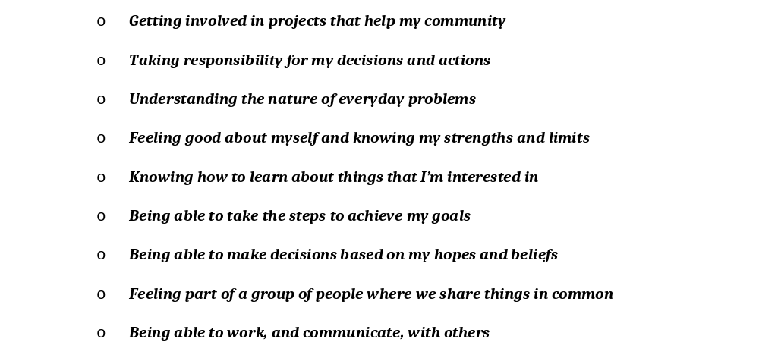
Having completed the ranking exercise, the participants returned to their pairs and trios to complete the Magic Booklet. The hidden section was revealed. Young people were asked to capture their thoughts on the benefits of youth empowerment, and the youth workers were asked what the youth project does to promote youth empowerment. When it became apparent that some of the youth participants struggled to contemplate this idea. We suggested that they could refer to the statements they had ranked for some inspiration, which some did.
In the final stage of the focus groups with youth participants and youth workers, they were invited to record their thoughts on feedback murals. On one mural, participants were invited to place an emoji sticker in the section that best reflected how they felt about the session e.g., happy, neutral, or unhappy, that captured how they felt about the session. On the other mural, they placed a sticker beside the statement that best captured their final thoughts in relation to the topic – see Image 1 as an example from the focus group with young people:

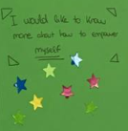
Image 1 I would like to know more about how to empower myself – Young People’s Mural
Individual reflections and the transcription of the focus group activities were analysed using Braun and Clarke’s (2022) process of thematic analysis. As an exploratory project, the intention is not to make claims about youth work and young people in Scotland. The themes, however, will serve as the basis of a future project involving youth workers and/or young people. The hope is that this article provokes some thought and discussion about current youth work practice, inviting practitioners to reflect on their own practice.

The Insights Gained

Overarching Theme From the youth perspective – The Individual Comes First
The magic booklet provided a space for self-reflection about power, the benefits to communities, but also about what it means to feel empowered. The young people appeared to be unfamiliar with the concept of power and empowerment; however they were prompted to give examples from their day-to-day experiences within school and within the youth project. The most important thing to them is that they have opportunities for self-development, from both the Magic Booklet and Ranking exercise. It is, perhaps, not surprising as the dominant educational experience they have had is within a formal setting. As some authors note (Ciraso et al., 2023; Sala-Torrent et al., 2024; Valdivia-Vizarreta et al.,2025), formal educators tend to focus on individual empowerment.

Although not articulated as such, most appeared to have exercised their power and agency in some way, giving examples of young people using their voice to shape the provision within the youth project, or talking to politicians or school leaders. Only two of the groups mentioned any connection to the wider community, and this ranked low for all the youth participants.
There was a sense that youth participation projects are beneficial to young people, as noted in Ward et al. (2024), bringing improvements in mental and physical health. A specific example was the sense within the group that building connections with peers and youth workers tackles poor mental health and isolation. As Sheykhi (2021) notes, young people face many challenges in their day-to-day lives. Navigating these requires great effort for some young people, leaving little energy or motivation for the collective effort. Perhaps the most striking finding of all was from the Evaluation Mural, on which the young people placed stickers beside a range of sentences. There were 8 stickers beside this sentence: I would like to know more about how to empower myself. This relates to one point noted in the Magic Booklet ‘sometimes things are complicated and we don't know where to start’. It is, perhaps, too easy to refer to the notion of youth empowerment without explicitly exploring what this looks like for young people.

Overarching Themes from Youth Workers’ Perspectives – Opportunities for young people to grow and develop, and Positive Relational Support
As a reminder, the youth workers were to answer from the perspective of young people in the Ranking exercise. In other words, they had to reflect on their conceptions (and even prejudices) that they have about the young people with whom they work. Most of the youth workers connected young people having power with volunteering, employability opportunities, and support programmes. This is reflected in the first theme that youth work provides opportunities for young people to grow and develop, resonating with the key theme from the young people’s

focus group. It could be concluded that their youth work provision stems from seeing young people as citizens, or even adults, in training (James and McGillicuddy, 2001). There were 30 mentions by youth workers about youth empowerment connecting to volunteering and opportunities for young people to develop skills. As an informal educational context, this does not reflect the findings from Ciraso et al’s. (2023) study, who noted that informal educators tend towards community empowerment.
The second theme, ‘Positive Relational Support’, relates to the perception that building connections through youth work can lead to benefits for young people. This
connects to Sheridan’s (2018) emphasis on creating the right space in which positive relationships can grow. Young people thrive in environments where respect, recognition, and a sense of welcome are present. However, barriers such as low self-esteem, a lack of role models, and inadequate support systems can hinder their empowerment. This reflects the point from the focus group with young people, that ‘young people sometimes feel anxious, even to ask for help’. Of note, there were 3 mentions that young people are not trusted, which may correlate with the two youth workers who did not participate in the ranking exercise as they felt young people would not be concerned about the dimensions of youth empowerment.
The predominant view from youth workers is that the youth project is actively promoting youth empowerment by providing a wide range of activities, training, and volunteering opportunities. However, 10 of the 15 youth workers noted that they do not think that young people think about their own empowerment.

Final thoughts

The relevance of youth workers regarding youth empowerment and one concern
Youth workers play a critical role in constructing empowerment processes through their professional practices and the meanings they attribute to empowerment (Valdivia-Vizarreta et al., 2025). As Ord (2007) noted, youth work must go beyond the teaching of functional skills by enhancing young people’s capacity for action within their communities. In this sense, youth work has historically been associated not only with individual development, but also with collective transformation and social change.
However, this article raises a significant concern. Although youth work in Scotland continues to provide important support for young people’s personal development and transformation, this does not necessarily translate into wider processes of community action or structural change. Despite the strong radical tradition of youth work grounded in Freirean critical pedagogy and collective transformation (Coburn, 2010), recent research suggests that contemporary youth work increasingly prioritises individual transformation over collective empowerment (Sala-Torrent et al., 2024; Valdivia-Vizarreta et al., 2025; Ciraso-Calí et al., 2023), including within the Scottish context (Ward et al., 2024).

The individual dimensions come first
The findings from these workshops suggest that youth workers tend to prioritise the individual dimensions of empowerment over collective and community-oriented aspects. In many cases, empowerment was framed in terms of self-sufficiency, responsibility, autonomy, and personal development, while collective dimensions appeared less present in the programmes described by participants.

However, focusing predominantly on individual responsibility risks reproducing neoliberal logics that overlook the social, economic, and political conditions constraining participation. From this perspective, empowerment becomes associated with adaptation and personal resilience rather than collective action or structural transformation. Drawing on Giroux’s (2024) framework, critical pedagogy offers an alternative approach by repositioning empowerment within broader struggles for social justice and the transformation of unequal power relations.
From this perspective, empowerment should not be understood as a purely individual attitude or competency, but as a situated individual and collective action aimed at transforming one’s environment. Empowerment depends not only on young people’s willingness or abilities, but also on the structural conditions, opportunities, and spaces available to them (Morcillo, 2026)

How can youth workers shift these inequalities?
Despite the meaningful support provided by educators, the findings suggest that youth workers may also reproduce adult-centric discourses and practices that constrain young people’s active participation in decision-making processes. This highlights an important tension within youth work practice, where support and empowerment can coexist with forms of control and unequal power relations. As Corney et al. (2022) argue, adultcentrism operates as a system of domination that privileges adult perspectives, limits young people’s autonomy and participation, and particularly affects those already experiencing social disadvantage. In this context, youth workers may unintentionally reinforce these dynamics when young people’s voices, capacities, or forms of participation are subordinated to adult expectations and institutional norms.

In this context, socio-educational support can play an important role in mitigating inequalities. Trull et al. (2025) found that young people identify youth workers and community resources as facilitators of participation and integration processes. Likewise, Kohler Gonzalez and de Fátima Guareschi (2009) showed that young people participate less fully in community projects when their power to make decisions is restricted. These findings reinforce the importance of relational support based on connectedness, horizontality, safe spaces, and meaningful participation. At the same time, the findings suggest the need to move beyond individualised approaches towards a stronger sense of community and mutual support. While individualism may weaken social ties and feelings of belonging, community spaces can foster recognition, hope, care, and collective engagement (Morcillo, 2026).
Valdivia-Vizarreta et al. (2025) further argue that educators should prioritise accompaniment and proximity while also promoting reflective spaces regarding professional practice. However, an important challenge emerges when many youth workers are unqualified sessional staff or volunteers who have not yet accessed professional training. This becomes particularly relevant in relation to what Crouzé et al. (2022) describe as the “civic empowerment gap”, whereby minorities, immigrants, and socioeconomically disadvantaged groups tend to participate less in civic life than dominant groups. In this context, youth work can become instrumentalised as a mechanism for integrating socially excluded young people into existing social orders, reproducing disciplinary and adult-centric models.
As the authors argue, youth workers are often positioned within a contradictory role: maintaining existing social structures while simultaneously supporting possibilities for individual and collective emancipation. Ciraso-Calí et al. (2023) found that informal educators tend to focus more on community empowerment, whereas formal educators prioritise

individual empowerment or individual development alone. This may suggest that the predominance of individual development within many youth projects reflects not only institutional pressures, but also limited understandings of what collective youth empowerment involves.
Overall, these findings reinforce the need to understand socio-educational action as a critical and emancipatory practice that goes beyond promoting the adaptation of young people to existing social structures. In this regard, youth workers should not only support individual development, but also act as agents of change capable of strengthening collective participation, questioning unequal power relations, and building bridges between young people, communities, and institutions (Morcillo, 2026). This requires stable socio-educational teams, reflective professional practices, and governance models based on dialogue and the meaningful inclusion of young people’s voices.

References
Braun, V. and Clarke, V. (2022) Thematic Analysis: A Practical Guide. London: SAGE.
Campbell, S., Greenwood, M., Prior, S., Shearer, T., Walkem, K., Young, S., Bywaters, D., & Walker, K. (2020). Purposive sampling: complex or simple? Research case examples. Journal of research in Nursing. 25(8), 652–661. https://doi.org/10.1177/1744987120927206
Checkoway, B. (1997). Core concepts for community change. Journal of Community Practice, 6(1), 11-29.
Ciraso-Calí, A., Sala, M., Pineda-Herrero, P., & Úcar, X. (2023). Youth Empowerment from the Educator’s Perspective: The Individual and Community Dimensions. Educar, 59(1), 231-248. https://doi.org/10.5565/rev/educar.1595

Coburn, A. (2010). ‘Youth work as border pedagogy’. In Batsleer, J., Davies, B. & Popple, K. What is youth work? (pp. 33-46). SAGE Publications, Inc., https://dx.doi.org/10.4135/9781526435873.n4
Corney, T., Cooper, T., Shier, H., & Williamson, H. (2022). Youth participation: Adultism, human rights and professional youth work. Children & Society, 36, 677–690. https://doi.org/10.1111/chso.12526 (Accessed: 18 April 2026)
Crouzé, R., Vanwing, T., & Meurs, P. (2022). Mind the Gap: The Potential of Professional Youth Work for Civic Empowerment and Engagement of Youth at Social Risk. Journal of Social Intervention: Theory and Practice, 31(3). https://doi.org/10.54431/jsi.716
Dunne, A., Ulicna, D., Murphy, I. & Golubeva, M. (2014). Working with young people: the value of youth work in the European Union: case studies. European Commission, February 2014.
Evans, P., & Kruger, A. (2012). Youth and Community Empowerment in Europe. Policy Press.
Freire, P. 1996 Letters to Cristina Reflections on My Life and Work, London & New York: Routledge
Giroux, H. (2024). Critical Pedagogy Against the Neoliberal Agenda in Education: The Stance of Critical Educators. Journal of Underrepresented & Minority Progress, 8(2). https://doi.org/10.32674/8a7gn586
James, T. and McGillicuddy, K. 2001. Building Youth Movements for Community Change. Nonprofit Quarterly. 18(4), pp.1-3.

Jennings, L. B., Parra-Medina, D. M., Hilfinger-Messias, D. K., & McLoughlin, K. (2006). Toward a critical social theory of youth empowerment. Journal of Community Practice, 14(1-2), 31-55.
Kohler Gonzalez, Z., & de Fátima Guareschi, N. M. (2009). O protagonismo social e o governo de jovens [social protagonism and the governance of youth]. Revista Latinoamericana de Ciencias Sociales, Niñez y Juventud, 7(1), 37–57. https://doi.org/10.11600/rlcsnj.7.1.216
Llena Berñe, A., Planas-Lladó, A., Vila-Mumbrú, C., & Valdivia-Vizarreta, P. (2023).Factors that enhance and limit youth empowerment, according to social educators. Qualitative Research Journal. DOI 1108/QRJ-04-2023-0063
Lundy, L. (2018). In defence of tokenism? Implementing children’s right to participate in collective decision-making. Childhood, 25(3), 340-354.
Morcillo, L. (2026). La participació juvenil des de la perspectiva de les persones joves: Una aproximació qualitativa als relats, significats i experiències des de la pedagogia social crítica. Ph.D. Thesis, University of Girona, Catalonia, Spain.
Ord, J. (2007). Youth work process, product and practice. Creating an authentic curriculum in work with young people. Dorset: Russell House.
Planas-Lladó, A., & Úcar, X. (2022). Evaluating Youth Empowerment: The Construction and Validation of an Inventory of Dimensions and Indicators. American Journal of Evaluation. Vol. 45(1) 86-109. https://doi.org./10.1177/10982140211055643

Sala-Torrent, M., & Planas-Lladó, A. (2024). Enhancing youth Voices: Exploring community participation through youth workers. Children and Youth Services Review, 160, 107600. https://doi.org/10.1016/j.childyouth.2024.107600
Sala-Torrent, M., Planas-Lladó, A., Soler-Masó, P., & Gómez, C. (2024). Evaluation of Youth Empowerment Projects From an Educators’ Perspective. Research on Social Work Practice, 34(1), 70-83. https://doi.org/10.1177/10497315221147532
Sheridan, L. Youth Participation in North Ayrshire, Scotland, From a Freirean Perspective. Ph.D. Thesis, University of Glasgow, Glasgow, UK, 2018.
Sheridan, L., & Mungai, M. (2021). Teacher-Student Reflections: A Critical Conversation about Values and Cultural Awareness in Community Development Work, and Implications for Teaching and Practice. Education Sciences, 11(9), 526. https://doi.org/10.3390/educsci11090526
Sheykhi, M. T. (2021) Observation of Youth in Sociological Context J, Clinical Medical Reviews and Reports. 3(7). https://doi.org/10.31579/2690-8794/091
Soler, P., Trilla, J., Jiménez-Morales, M., & Úcar, X. (2017). La construcción de un modelo pedagógico del empoderamiento juvenil: espacios, momentos y procesos. Pedagogía Social. Revista Interuniversitaria, 30, 19-34.
Trull-Oliva, C., Fabra-Fres, M. N., Núñez, H., & Corbella, L. (2025). The Sense of Community in the Improvement of Youth Empowerment: Contributions from a Socio-Educational Research Experience. Journal of Community Practice, 33(4), 467–486. https://doi.org/10.1080/10705422.2025.2605320
United Nations. General Assembly, & Canada. Human Rights Directorate. (1991). Convention on the rights of the child. Human Rights Directorate.

Valdivia-Vizarreta P, Carrera-Fossas E, Sala Torrent M, Planas A (2025), "Balancing individual and community dimensions: educators’ narratives on youth empowerment". Education + Training, Vol. 67 No. 7-8 pp. 737–751, doi: https://doi.org/10.1108/ET-05-2024-0244
Ward, S., McBride, M. and Watson, N. (2024) Evaluating youth empowerment in neighbourhood settings: applying the capabilities 3C model to evidence and extend the social justice outcomes of youth work in Scotland. Journal of Youth Studies, 27(1), pp. 125- 140. (doi: 10.1080/13676261.2022.2112160)
Yin, R.K. 2012. Applications of Case Study Research 3rd Ed. London: Sage Publications
Zimmerman M.A. (2000) Empowerment Theory. In J. Rappaport & E. Seidman (Eds.), Handbook of Community Psychology. Springer. https://doi.org/10.1007/978-1-4615-4193-6_2

This study was supported by the project “Learning through young people's social participation. Its contribution to youth empowerment in youth trajectories. (4HEBE)” Ref. PID2023-147368OB-I0, funded by MICIU/AEI /10.13039/501100011033 and FEDER, EU.

